VOIP lab experiment#10
Uploading the wav message into the system recordings

Installation and Repair of Telecommunications Equipment

Name of student:________________
Group Number:_________________
Date:_________________________

The purpose of the lab is to upload the wav message from laboratory 7 into the system recording.

- Go to system recordings located into admin menu:
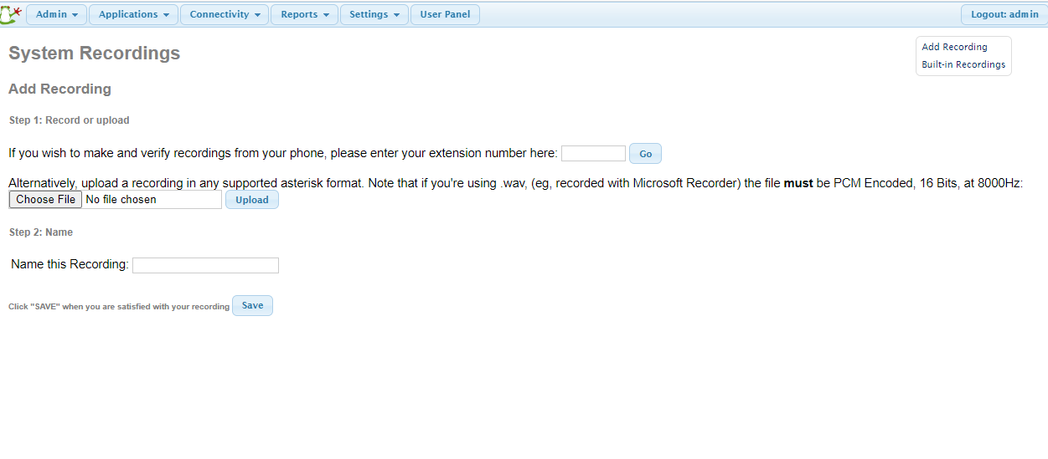
- Click on browse and choose the audio file that you saved earlier and the click on upload

- Click on save

- Submit changes and then click on apply config.

